**Project Report: Modernizing Data Platform for ABC Corp**

**Project Overview:** ABC Corp, a leading Manufacturing - Consumer Goods Company, is embarking on a journey to modernize its data platform to address challenges stemming from aging architecture, operational silos, performance bottlenecks, and untapped data. This project aims to develop a scalable Data and Analytics Infrastructure on the cloud, enabling real-time data availability, reducing costs, and enhancing productivity across different entities of the organization.

**Key Objectives:**

1. Develop a scalable Data and Analytics Infrastructure on the cloud.
2. Overcome performance bottlenecks and reduce costs.
3. Enable real-time data availability across different entities.
4. Support operational reporting, BI reporting, ad-hoc reporting, and analytics needs.
5. Ingest data from various sources including 3rd party sources.

**Project Phases:**

Assessment and Requirement Gathering:

* Conducted a comprehensive assessment of current infrastructure, data sources, and business requirements.
* Engaged stakeholders from Marketing, Sales, Operations, and IT departments to gather inputs and understand pain points.

Define Architecture and Technology Stack:

* Developed a detailed architecture blueprint based on assessment findings and business objectives.

Data Diagram-

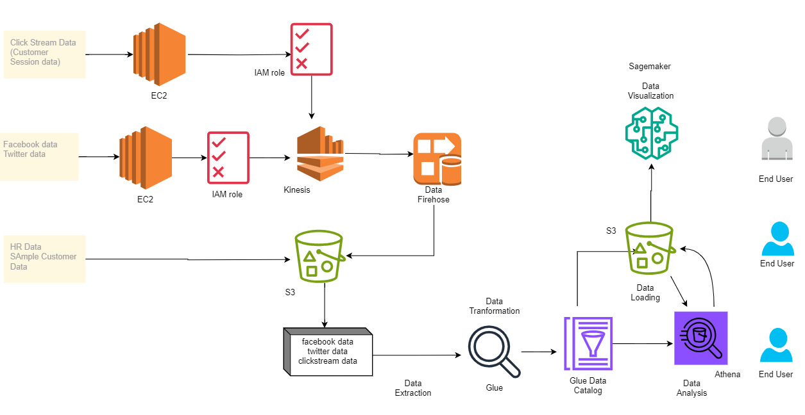

* Selected appropriate cloud platform (AWS), data lake (Amazon S3), real time streaming (Amazon Kinesis, Firehose),ETL job(AWS Glue), Querying (AWS Athena),Amazon EC2.
* For Storage we can also use Redshift, RDS.
* For Business Intelligence QuickSight, PowerBI, Tableau.

Implementation:

* 1. Data Sources:  
       * Clickstream data

Created a fake data set using faker and then streamed it to Kinesis using EC2 and IAM role to give permission to EC2 for interacting with S3 and Kinesis

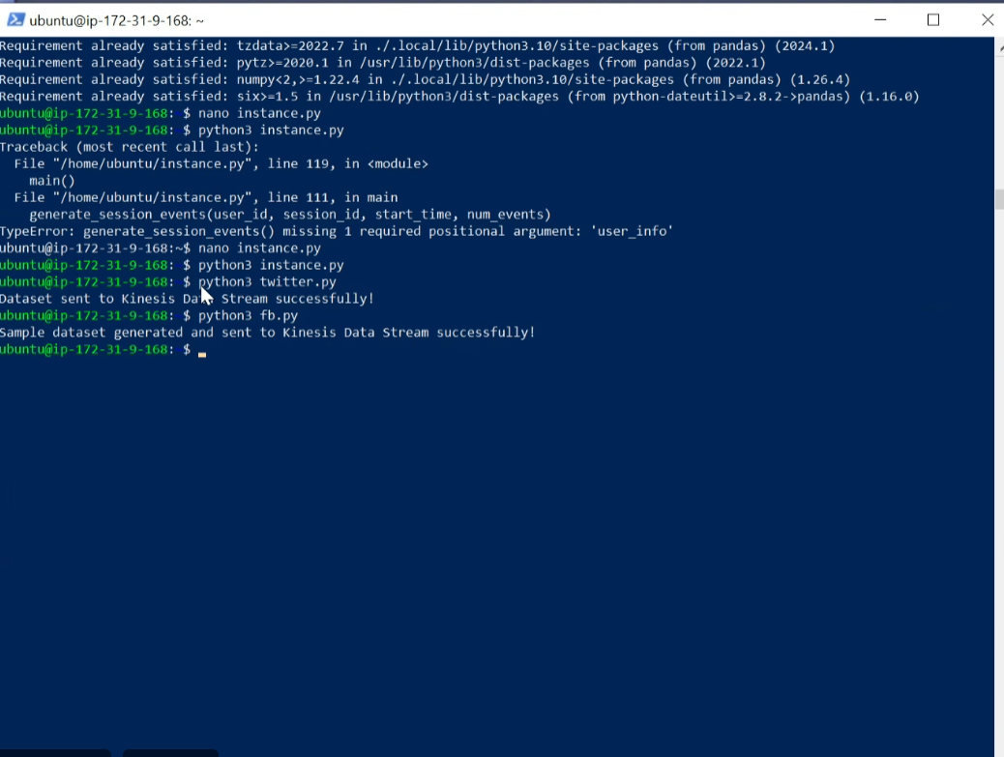

Using python file instance.py created a dataset, and then streamed the data to kinesis data streams

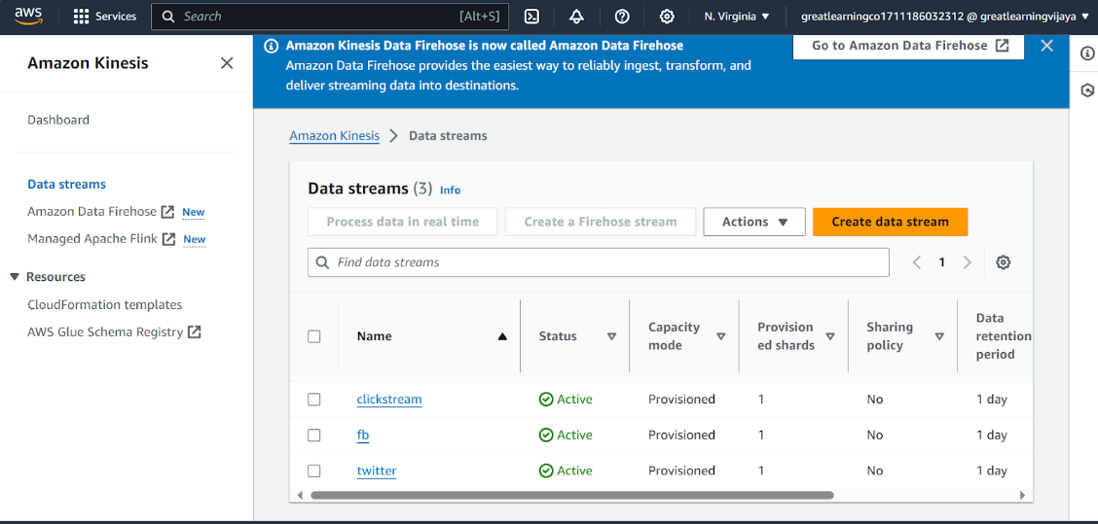

Arrived events in kinesis,

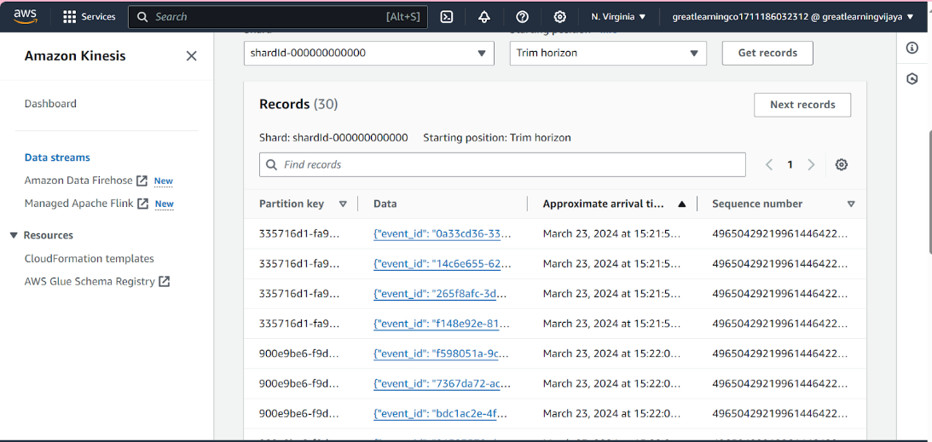

  * Twitter API data

Similarly for Twitter data,



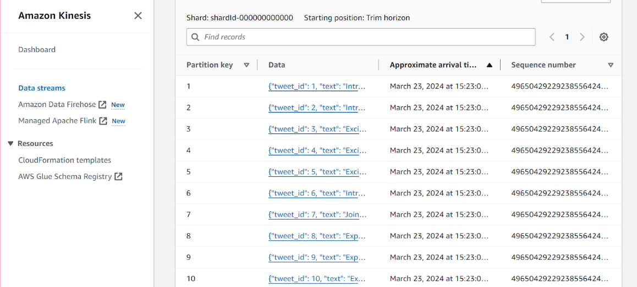  
  * Facebook API data

Similarly for Facebook data,



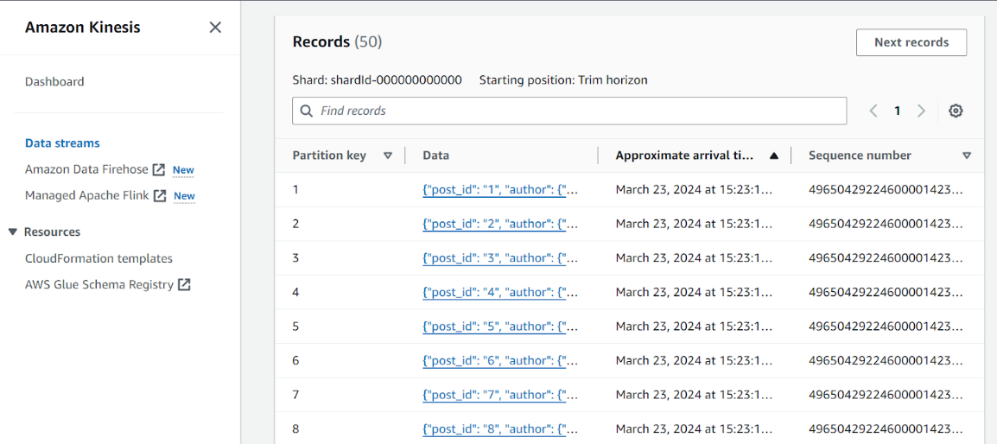  
  * HR data (already in S3),Sample customer data(in S3)

2. Ingestion of Data:  
  * Deliver the data to an S3 destination folder using Kinesis Data Firehose.

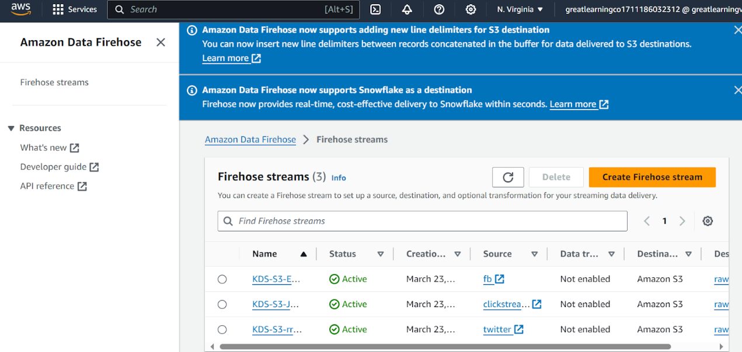

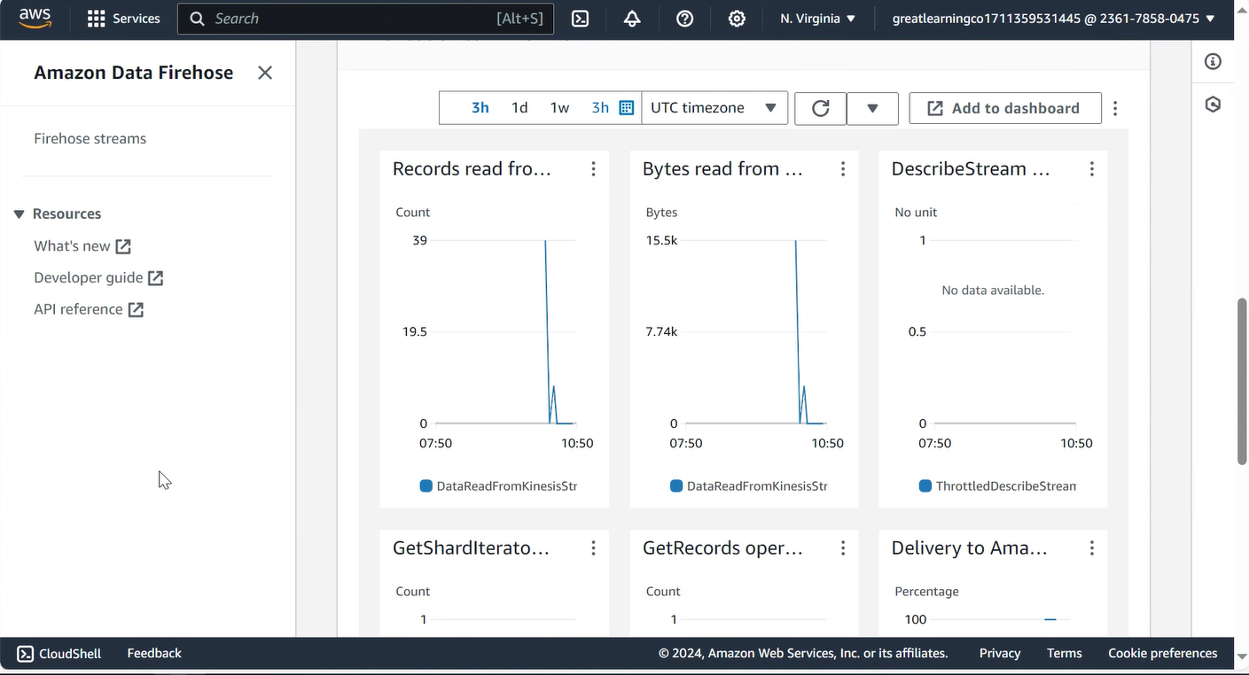

Data in the destination S3 bucket,

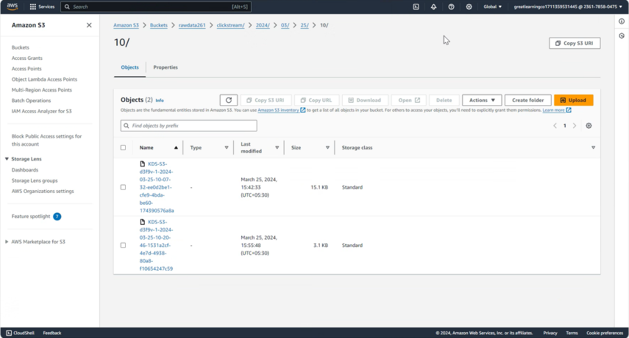  
3. ETL Job:  
  * Schedule an ETL job to run every two hours.

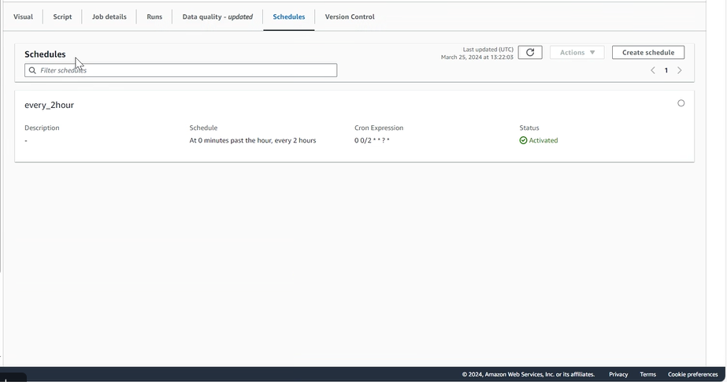  
  * The ETL job transforms the dataset and stores it in an S3-backed catalog table.

For Clickstream ETL pipeline,

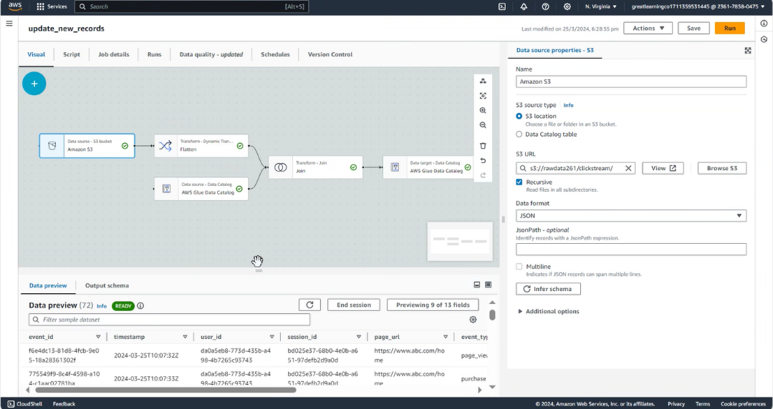

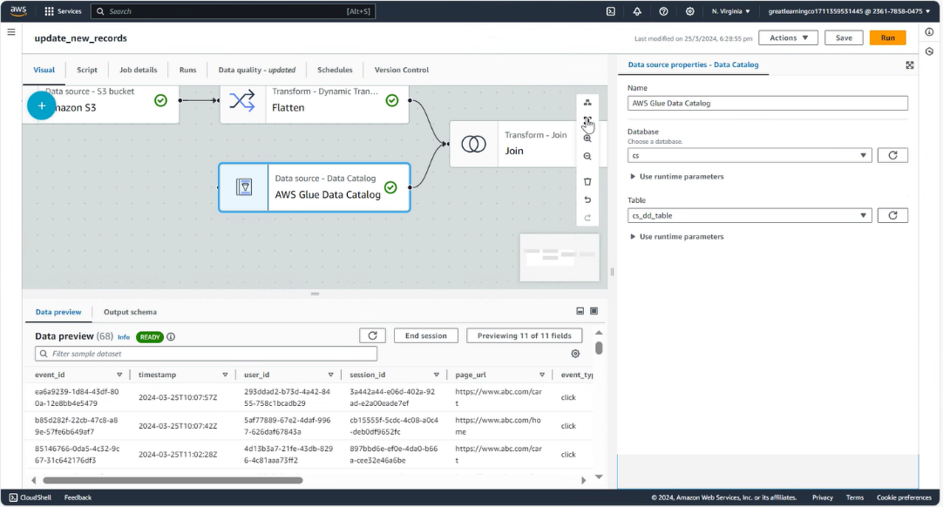

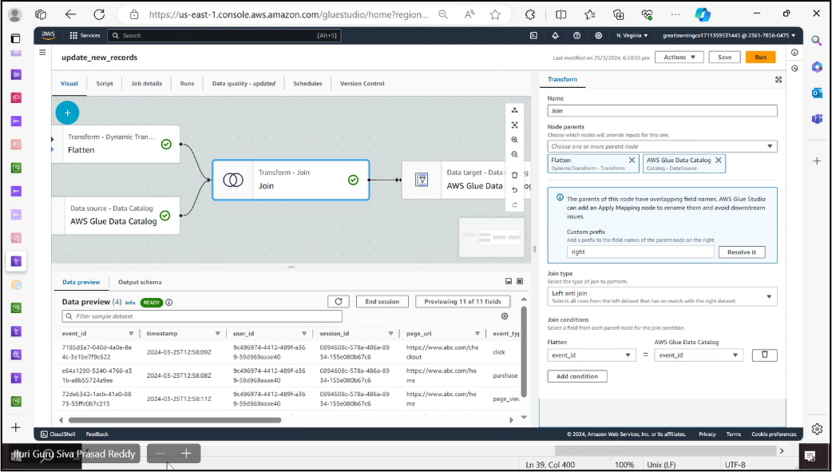

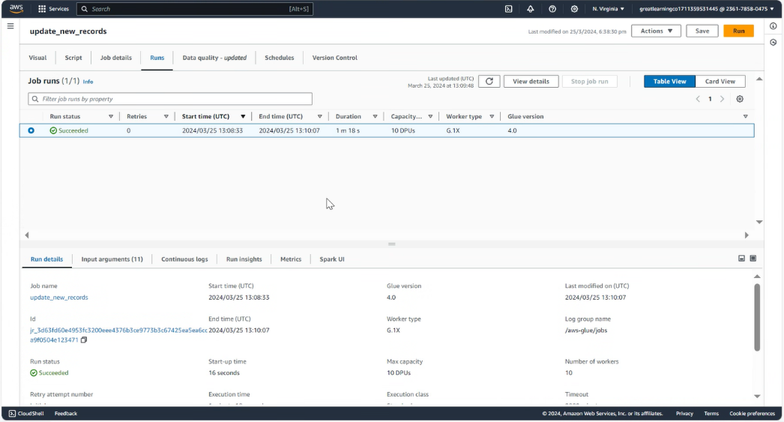

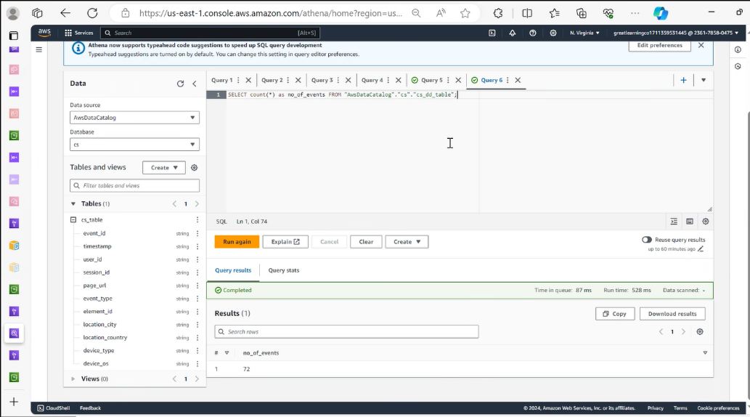

Pipeline for Twitter, here instead flattening the json, as there are some array objects we applied a transformation explode the array.

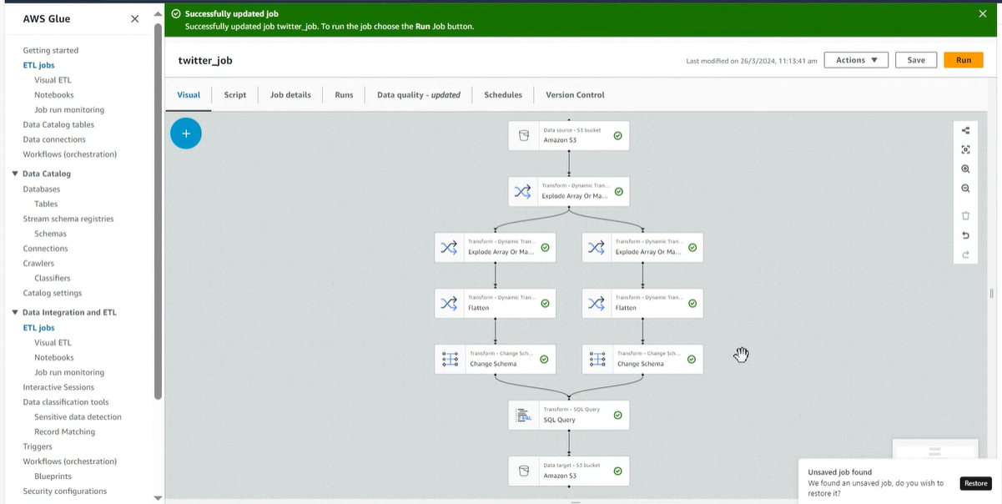

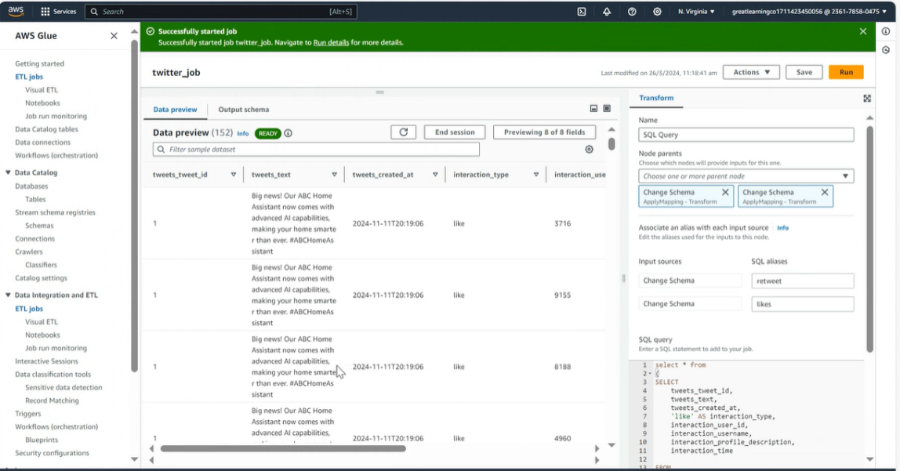

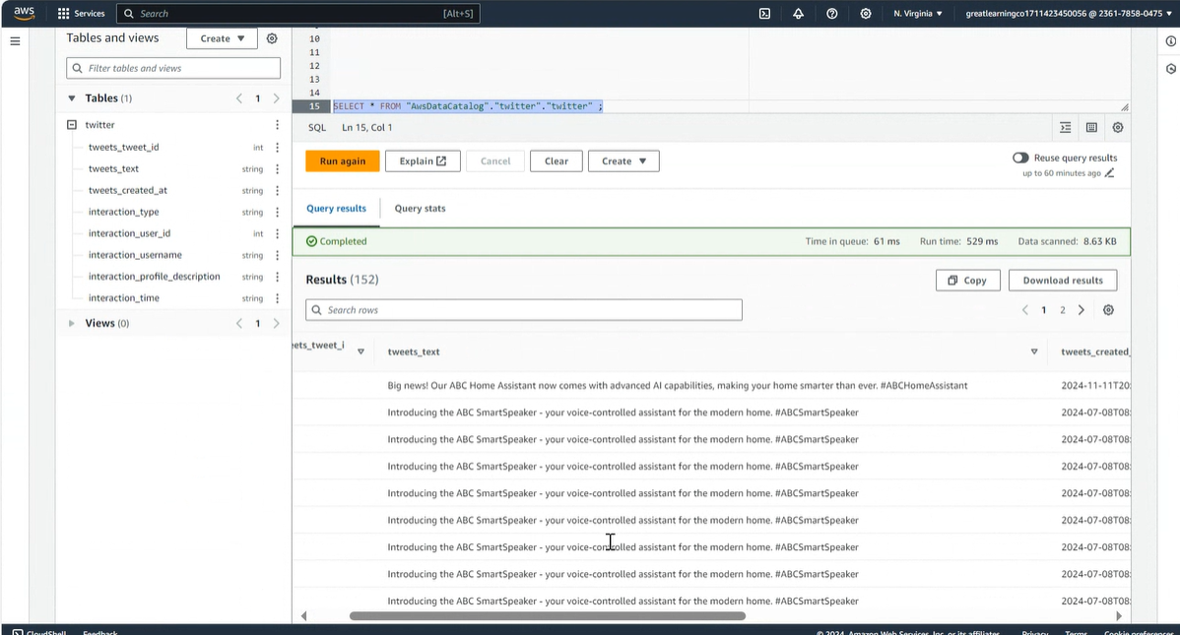

Similarly for Facebook data, Here from the json data we have created users table, posts table, comments table, likes table.

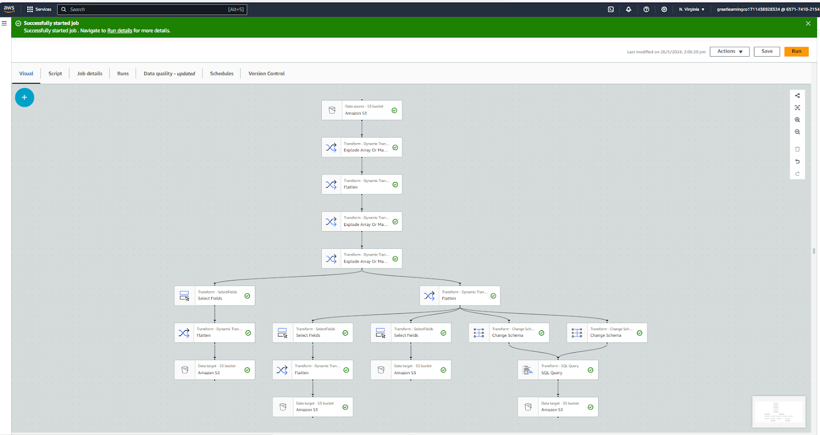

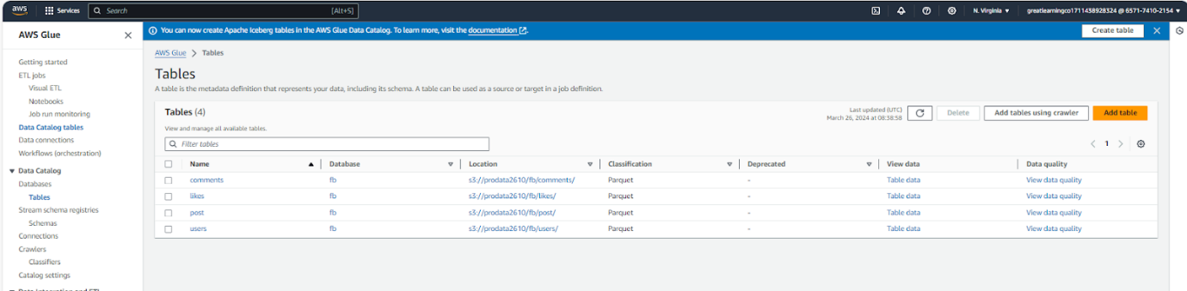

Comments table:

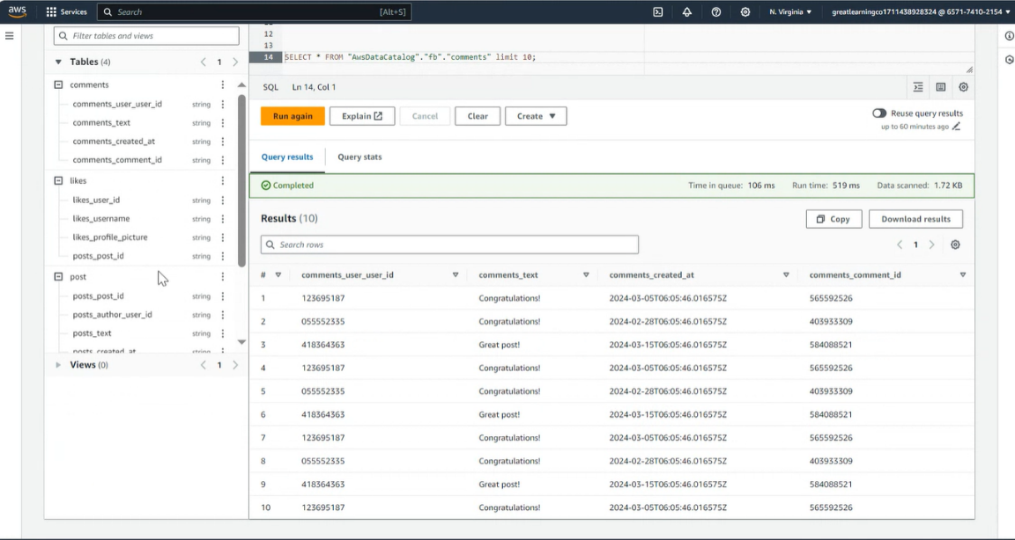

Posts table:

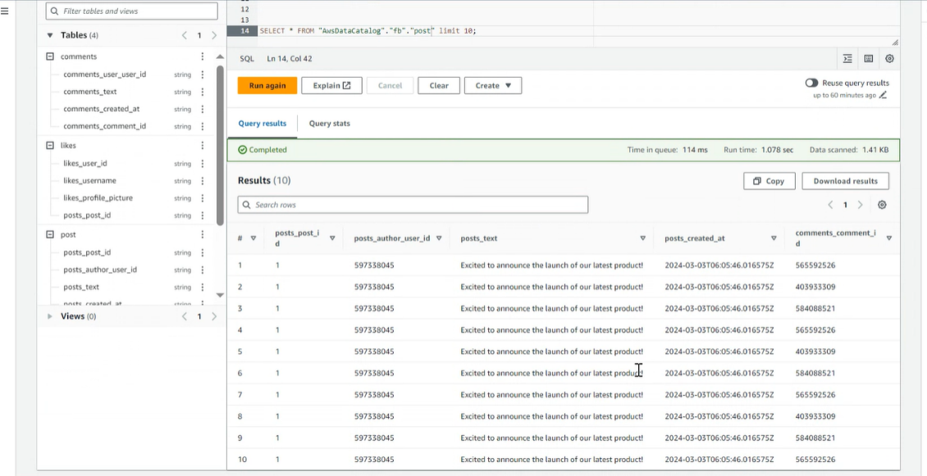

Likes table:

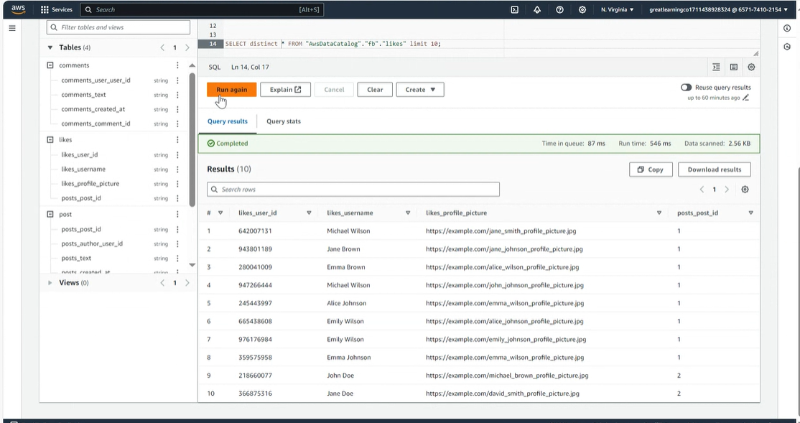

Users table:

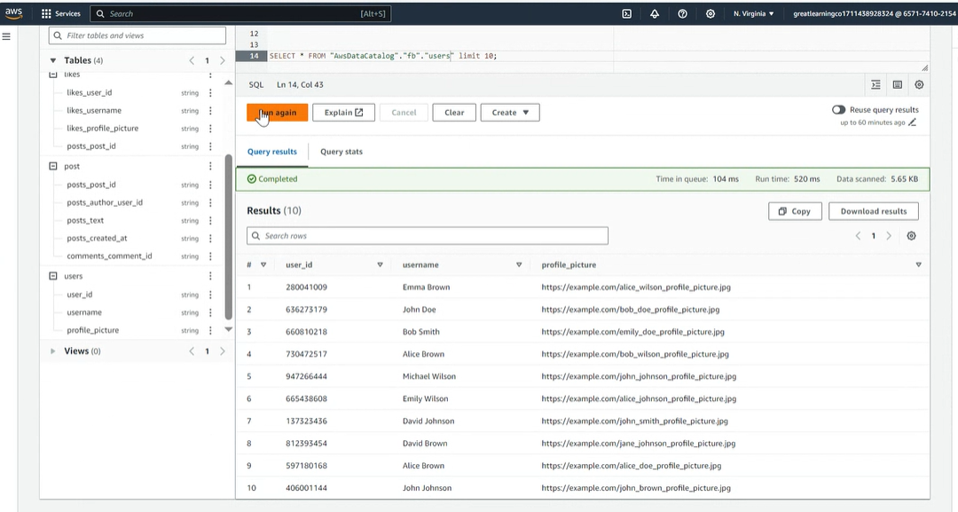

ER Diagram for this data:

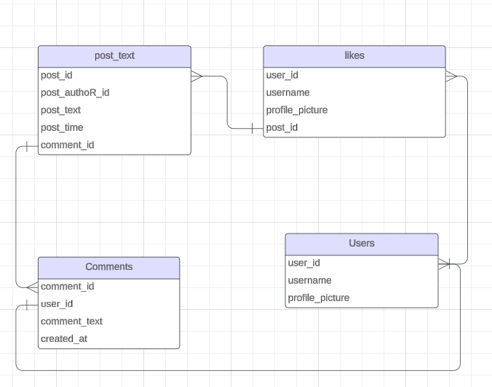  
4. Data Analysis:  
  * Use Amazon Athena to load and analyse the data.

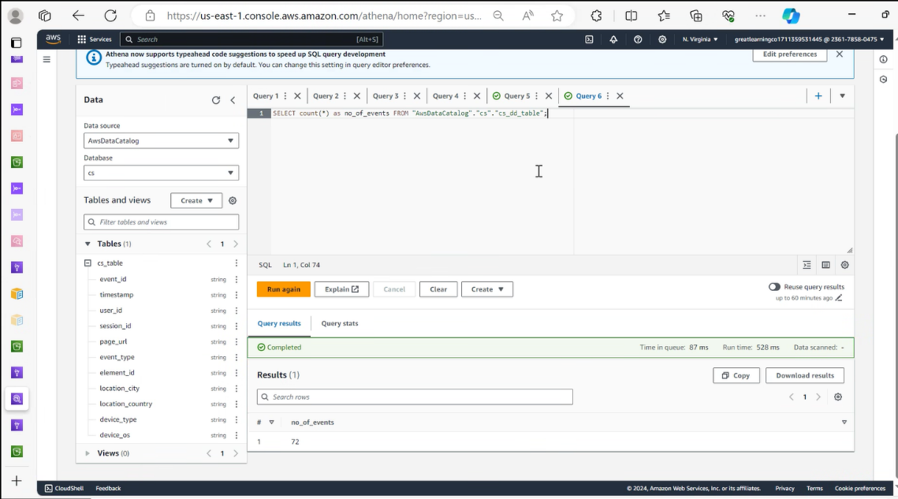

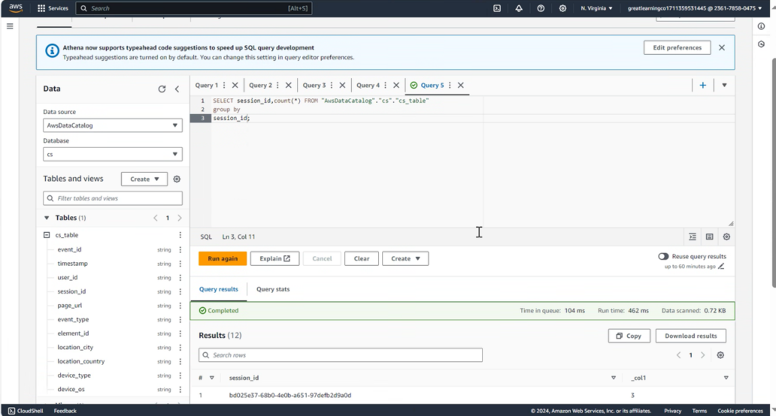

Like this we can query and analyse the data.  
5. Data Visualization:  
  * Use Amazon Sagemaker to visualize the data.

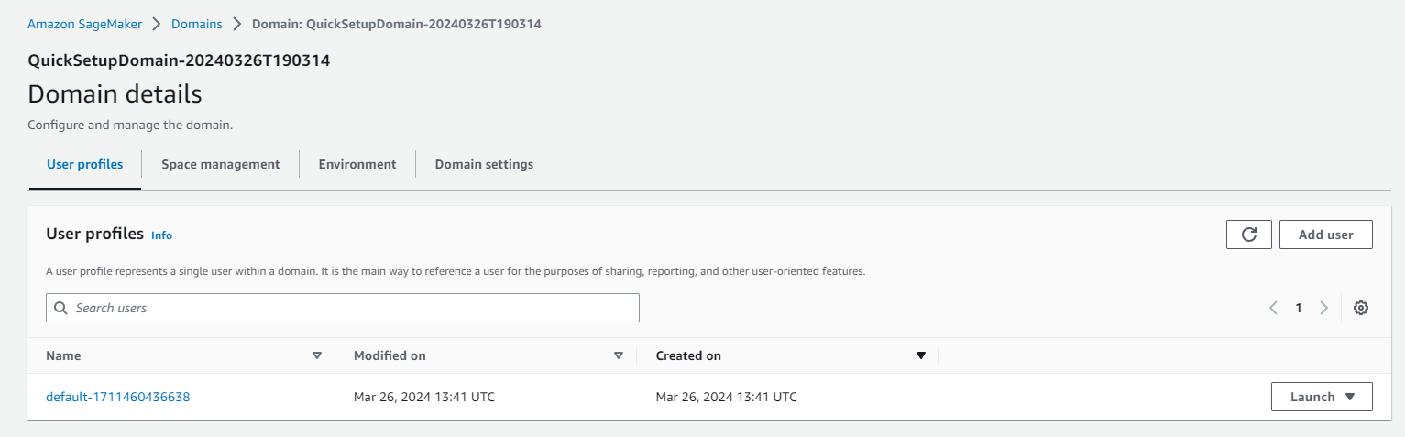

: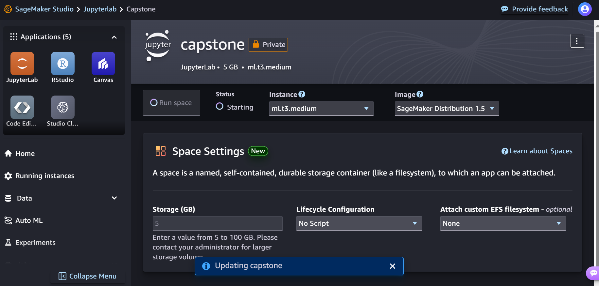

Some of the visuals created are : for HR data

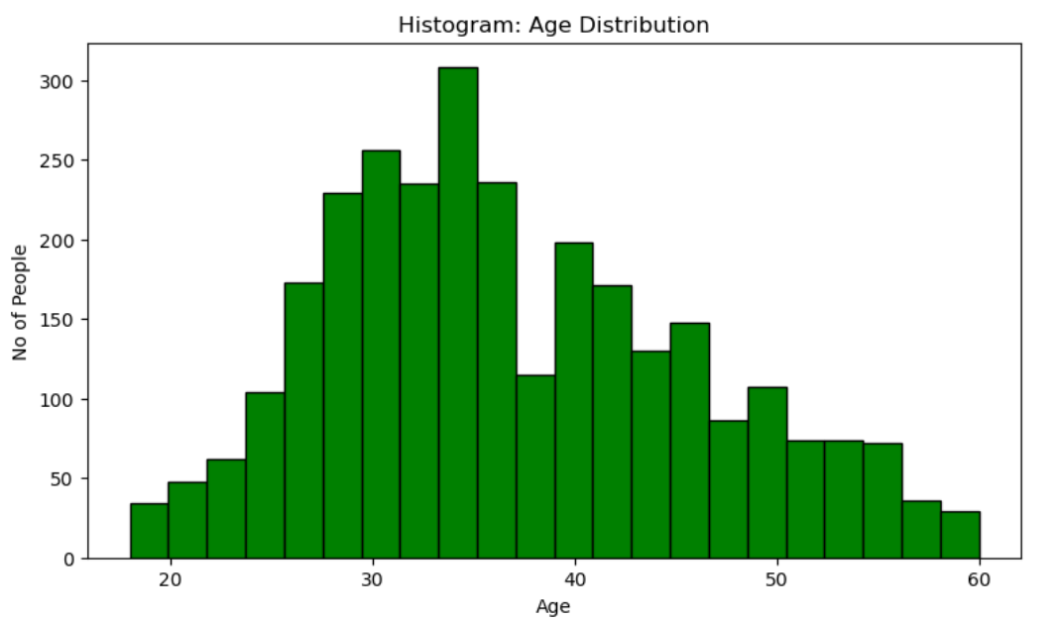

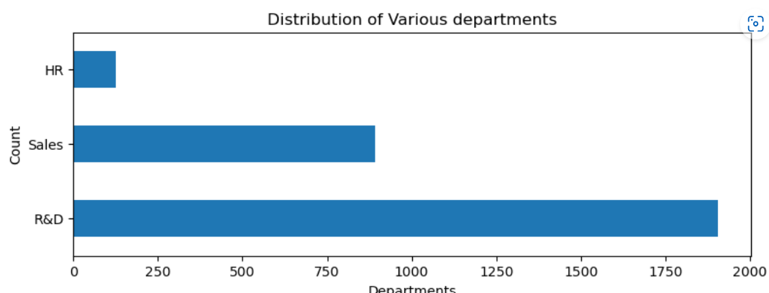

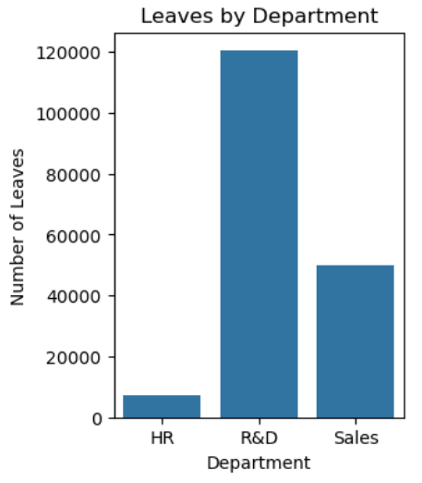

from Clickstream data, here user and his first purchase and session durations is shown

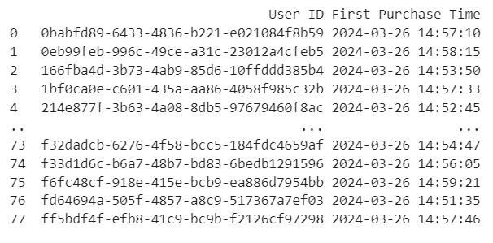

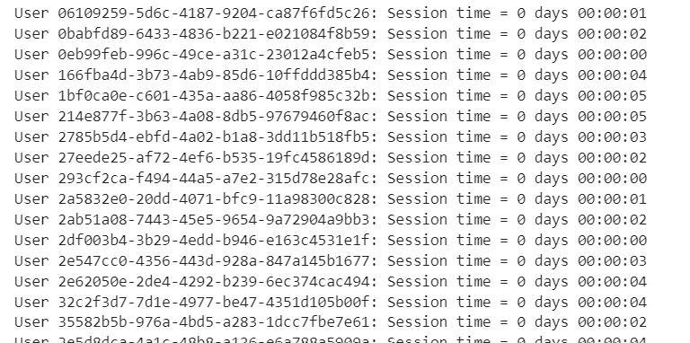

**Challenges and Mitigation:**

Technical Challenges during Migration:

* + Addressed through thorough planning, testing, and collaboration with technical experts.

Stakeholder Resistance to Change:

* + Mitigated through effective communication, training, and change management strategies.

Budget and Timeline Constraints:

* + Managed through careful resource allocation, prioritization, and contingency planning.

**Budget Estimation:**

Using the AWS pricing calculator ,created a rough estimate of the budget .

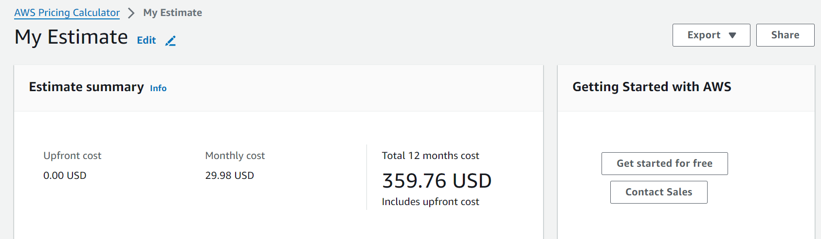

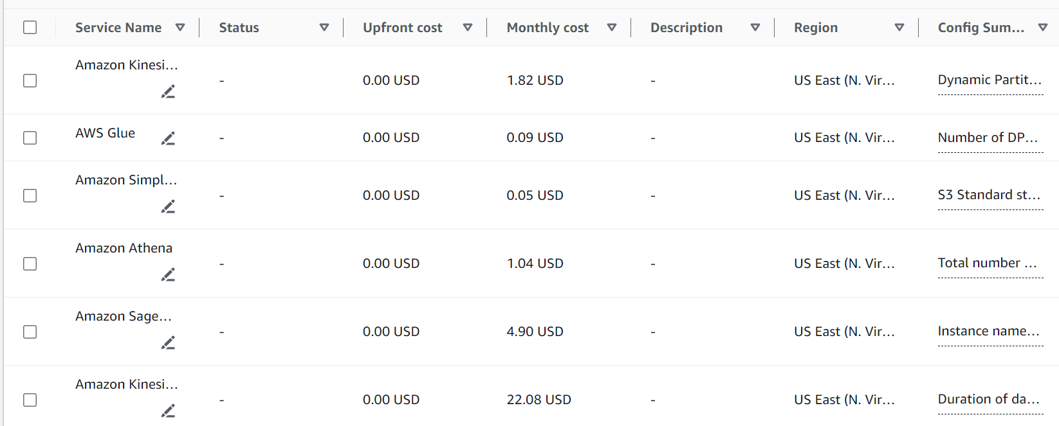

**Success Criteria:**

Initial Module:

* + Successful migration to cloud platform.
  + Improved data availability and performance.
  + Adoption of BI reporting and analytics tools.

Ongoing Program:

* + Continued optimization and scalability.
  + Positive impact on business operations and decision-making.
  + Stakeholder satisfaction and engagement.

**Conclusion:**

The modernization of ABC Corp's data platform is a strategic initiative aimed at driving efficiency and insights across the organization. Through collaborative efforts and a phased approach, we have laid the foundation for a scalable, cost-effective, and future-proof solution. Continuous monitoring and optimization will ensure that the platform evolves to meet the evolving needs of the business.